egoboo
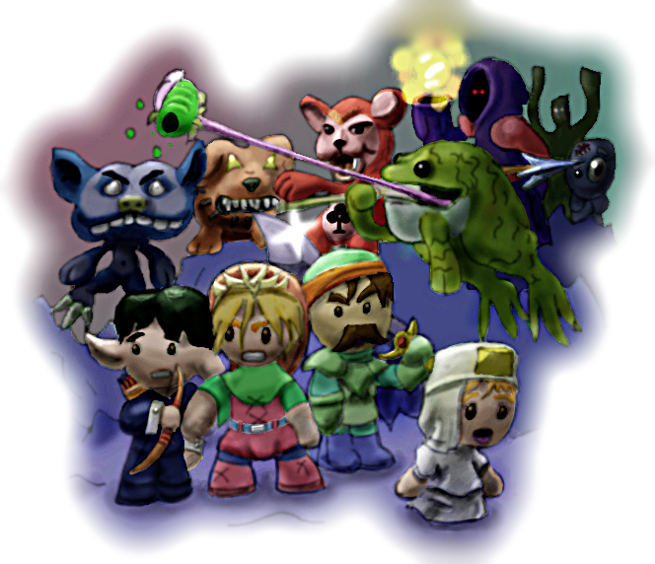
Quick Start Guide
-Johan Jansen
Contents
Minimum Requirements 3
Beginning 3
Starting a new character 3
Continuing your path to glory 4
Death 4
Loading and Saving 5
Loading a game 5
Saving your game 5
Player Display 7
Game Settings 8
Keyboard Controls 8
General Keys 8
Default Keys for Keyboard 8
Changing the controls 9
Sound Options 9
Video Options 9
Game Options 11
Installation Guide 12
Windows 12
Linux 12
Macintosh 13
Support and Contact 14
Troubleshooting 14
Online community 14
Development Credits 16

Minimum Requirements
These are the minimum we know it works on, but it might very well work on less. Tune down some graphical effects if your frame rate is low.
Processor: Pentium III/Athlon with 2.0 GHz or more
Memory: 256 MB RAM (512MB RAM Recommended)
Video: Any graphical 128 mb GFX card supporting OpenGL 2.0 or better
Sound: Any sound card will do.
Multiplayer: For hotseat mode, Egoboo requires gamepads, joysticks or a connected mouse. Internet or LAN/UDP is currently not supported.

Beginning

Starting a new character
To begin play as a new character simply click the New Game button in the main menu, which will take you to the list of starter games that you can play without a saved character. Clicking on any of the game icons will bring up a description that includes brief introduction to its plot and level of difficulty. Each of these games is a fun and challenging tutorial for one of the basic character classes in the game. Just click on Select Module to begin!
You will start out as a sad little first level character who has one big problem. But take heart, because your little guy has everything everything to save the day and maybe even a kingdom! Solving the quest and completing the module will introduce you to the character's skills and weaknesses and teach you something about the strategy you will need to be successful. If you complete the tutorial, your little hero will be saved and you'll be able to take him through bigger and better adventures.
Each tutorial focuses on one basic character class. If you dream of being a mighty warrior adept in the arts of combat, try the soldier. If the magic of the quiet forest glades stirs your soul, you are an elf. If wanton destruction and silliness are the requirements for being a G'nome. The Adventurer is a jack-of-all trades... you get the picture.
If you are a new gamer or find the other modules too challenging, we recommend you try the Soldier or the Adventurer tutorials.

Continuing your path to glory
To continue a saved game, click on the Load Game button in the main menu. This will take you to the list of your saved characters. Scroll up and down the list until you find the character you want and then click on one or more of the input devices you want to use for your character, in case you want to be able to use a combination of keyboard and joystick commands. Enabling input devices for more than one character will start a multi-player hotseat game.
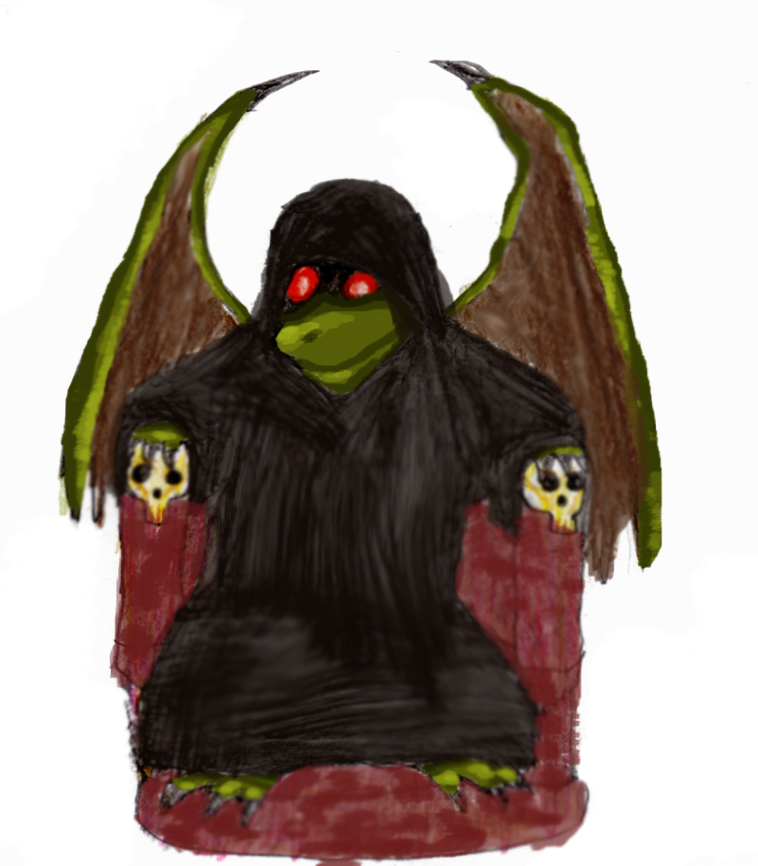
Choosing the Select Player button will take you to a screen where you can choose your next adventure. The games that appear on this screen will show you all your available options depending on what quests you have and which you have completed. Clicking on any of the game icons will bring up a description that includes brief introduction to its plot and level of difficulty. Click on Select Module to begin the death and destruction...
As you go deeper into the game, you will discover more and more of the dangerous plot that threatens the world of egoboo. Each successful step will unlock more of the game.

Death
No matter how many life potions you were able to stuff down your tunic, it is very likely you will eventually die. Don't worry too much because you can almost always bounce back from death. Of course, there are always penalties... though you do not have to worry about loosing you character!
Most of the time you can respawn in a safe location. You will drop everything you were carrying in your hands and some of the coin you were carrying. The grim reaper will also charge you a base 15% death tax on you accumulated experience points and on your character's cash.
But sometimes your character just doesn't bounce. Some special modules prevent respawning completely, and in Hard Mode respawning is completely turned off. In this case, your only hope is to play a multiplayer game with someone who likes to be a healer. have a buddy multiplayer game
The last way to avoid death is to bring a Healer and a couple of scrolls of Rebirth along with you. Having her read the scroll over your dead body will completely avoid the death tax.

Loading and Saving

Loading a game
To continue playing a previous character, simply press the Load Game button in the main menu. This will take you to a player selection screen where all of your saved players will be listed. Scroll up and down the list until you find the character you want and then click on one or more of the input devices you want to use for your character, in case you want to be able to use a combination of keyboard and joystick commands.
Enabling input devices for more than one character will start a multi-player hotseat game. While this can be played with one player using the keyboard and the other player using a combination of mouse and keyboard commands, we recommend that at least one player use a USB joystick.
After selecting the character(s) you want to play, click on the Select Player to go to the screen where you can choose your next adventure. Every game that your adventuring party qualifies for will be displayed in this menu. The number an variety of the games that are displayed can vary widely, depending on which character(s) have been selected and what quests they have completed. Do not be discouraged if only a few games show up on the screen. As your little hero gets more experience, you will see more and more games. And don't forget to check the new game menu from time to time. Who knows what you may have unlocked while you were away!
Selecting on a game icon will bring up a description that includes brief introduction to its plot and level of difficulty. Click on Select Module to begin the hack and slash... maybe there will be a bit of weeping in there, too...

Saving your game
If you are a super-duper iron man gamer who can complete complex games in a single sitting, you have no need for this section. For the rest of us who need to eat and take bathroom breaks, being able to save your progress is a must!
Both saving and exiting the game requires that you pull up the in-game menu by hitting the escape key. Among the various options you will either see a button that says either Save and Exit or Quit Game , depending on what you were doing in-game.
You will be able to save your progress any time you have completed a game. This usually requires completing a specific task, like such as killing a boss monster, finding a magic item, or saving some townsfolk. You will also be able to save whenever your character is in a “safe” environment, like a city.
This will save all of your advancement through the game and all of your character's inventory. Any item that you are not holding will be lost forever, so make sure that you do not leave that magical armor lying on the floor and that you pick up your trusty pet bunny rabbit!
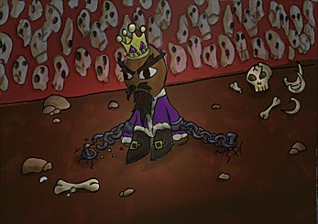
This highlights the most obvious problem with saving. What happens if you have lost that key that you're going to need in your next adventure? Or maybe your character has been kissed by a vampire a couple of times and is too weak to move... hmmmm... I just had an awful flashback... (shiver)… In that case, you will be happy to see the Quit Game or the Restart Module button, which will allow your character to forget everything that will give him nightmares and post traumatic stress and just start over. In fact, this may be necessary in the more challenging modules, where no amount of brute force hacking or spell nuking if going let you win.

Player Display
On the right-hand side of the game screen, you will see status displays for each member of your party. For each member, you will see the character's name, how much money they are carrying, three little portraits, and one or two status bars below. The center shows your character's physical appearance and armor. The portrait on the left and right show the items being carried by the left and right hands.
 | 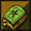Dead | Dead | Dead
 | Left hand |  | Right hand
Dead | 
Life | 
Divine Mana | 
Poison | 
Special Effect | 
Arcane Mana | l
The red status bar is your life. When this bar is empty, your character dies. The other bar is usually the magical energy of your character, mana. Both life and mana will regenerate slowly over time. If you get impatient, you can always find potions to speed up the process.
If one of your status bars changes color unexpectedly, something strange has happened to you. For example if the life bar has changed to green you've been poisoned.
While playing you can press 1, 2, 3 or 4 to display detailed character information for the various members of your party. To save space, the information is presented using the following codes
STR - Strength. Directly adds bonus damage to most melee weapons, unarmed attacks and longbows. You need 21 strength to use the Maul of the Titans. Increases chance to correctly block an attack with an shield.
WIS - Wisdom. Reduces chances of poisoning self. Increases damage/ effect of all Divine spells. Reduces damage taken from arcane spells. Increases resistance vs. Bind spell. Increases chance to find hidden bottoms in chests.
INT - Intelligence. Required to read specific scripts and identify special items. Increases damage dealt and control for all Arcane spells. Reduces damage from divine spells. Slightly increases reload time for gunpowder weapons.
DEX - Dexterity. Increases aim for ranged weapons and spells. Increases attack speed with all weapons. Increases chance to sneak. Adds bonus damage to backstabs.
DEF - Defense. Every point of defense adds about 0.4% damage reduction. Someone with 70 DEF reduces all damage taken by about 27% (After applying damage resistances)

Game Settings

Keyboard Controls

General Keys
These are default keys and cannot be changed.
- Escape opens the in-game menu
- 1, 2, 3, and 4 give character stats (Holding SHIFT, CONTROL or ALT while pressing a number button displays more detailed information)
- SPACE is used to respawn if you have died
- F11 makes a screen shot

Default Keys for Keyboard
- Arrow keys move the character
- SPACE makes your character jump
- T use left hand items
- G drop or grab left hand item
- B rotate right hand inventory
- Y use right hand item
- H drop or grab right hand item
- N rotate right hand inventory
- 5 and 6 rotates the camera
- + and - zoom the camera

Changing the controls
You can simply change the input controls for the keyboard, mouse or gamepads through the Input Settings menu. In the main menu, simply click the Options button to find the Input Settings menu.

Sound Options
This section describes what all the sound options do.
In this menu you can enable or disable sound and music or change the volume of either.
SOUND CHANNELS: This specifies the maximum number of sounds that can be played simultaneously.
BUFFER SIZE: Default is 2048. Only change this if you hear stuttering in your sound effects.
HIGH SOUND QUALITY: This will allow high quality sounds to be fully loaded into memory. This might make some sounds better but reduces performance.

Video Options
This section describes what all the video options do.
SHADOWS: Off, Normal or Best. This setting determines how good the in-game shadows look.
TEXTURE FILTERING: This option sets which kind of texture filtering you want to use. Unfiltered being the fastest and ugliest option while Trilinear 2 being the best and most performance heavy option. If your video card supports it, there is an Anisotropic option which is the absolute best filtering mode.
REFLECTIONS: Off, Low, Normal or High. Determines how good reflections look in-game. Low enables character reflections, while Normal also enables particle reflections. High adds reflection fadeout. Off disables all reflections.
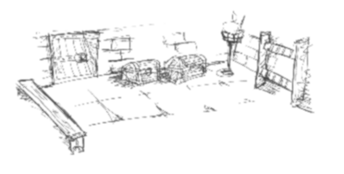
FULLSCREEN: Enables or disable full screen. Requires a restart to take effect.
MAX LIGHTS: Determines the maximum number of dynamic lights. If your frame rate isn't too slow, set this to a high number.
3D EFFECTS: This option will increase 3D quality and enable special 3D effects.
GOOD WATER: Allows multilayer water and makes water quality much better.
MAX PARTICLES: Sets the maximum limit of particle effects in the game. Increase this to a high number make certain special effects such as spell or explosions look better.
RESOLUTION: Changes the game resolution. You can specify wide-screen resolutions manually in setup.txt (located in the Egoboo folder).
The following are advanced settings, which should not be altered unless you understand what they do and know that your graphics hardware supports the values you choose. An incorrect value could result in the game being unable to start. If you run into such an error check the debugging output in logfile.txt.
ANTIALIASING: Off or X1 to X4. Anti aliasing makes everything in the game look sharper and minimizes distortion artifacts. This option is performance heavy and can be repeated 1 to 4 times (four being best and most performance heavy).
DITHERING: Enables or disables dithering. This can make textures smoother on low color bit settings.
Z-BIT: Usually available in 8, 16, 24, or 32 bits depending on your graphics card. The z-buffer is what allows the computer to draw nearer objects in front of farther objects. If you see some strange graphics glitches where the depth of an object seems confused, increase this setting. Smaller numbers are faster because they require keeping track of less graphics memory.

Game Options
General game settings are covered in this section. Most important on this screen is the difficulty setting which can affect your game play a lot.
GAME DIFFICULTY: This will affect certain aspects of the game. Note that Hard mode will also give a 20% XP bonus and Normal a 10% bonus to XP while in Easy mode you gain no XP bonus and you cannot unlock the final level! Certain puzzles and bosses can get harder/easier depending on difficulty. The effects of every difficulty are described below the button.
MAX MESSAGES: The maximum number of messages to be displayed on the screen.
MESSAGE DURATION: This determines how long messages are displayed before they disappear.
AUTOTURN CAMERA: Enables or disables that the camera rotates automatically when the player moves around. If set to Fast, the camera will rotate left if the player moves left and rotate right if the player moves to the right.
DISPLAY FPS: Hides or shows the current Frames Per Second count.

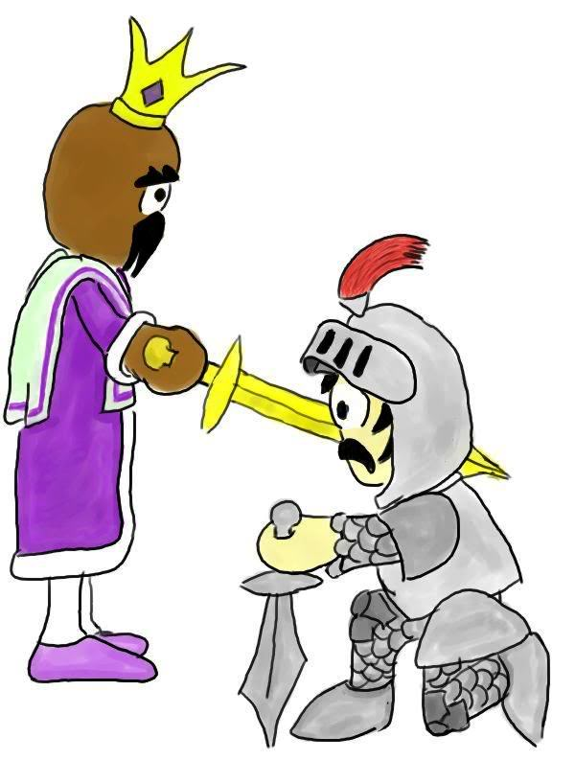
Installation Guide
Egoboo runs under Windows, Linux and Macintosh. Here is a guide how to get the game to work under each operating system:

Windows
Windows users simply run the installer and install the game to a directory of your choice. Simply run Egoboo.exe to start the game. All required software to run the game should be included and automatically installed along with the game. The game has been tested and runs fine under Windows 95, Windows 98, Windows 2000, Windows XP, Windows Vista (with compatibility mode) and Windows 7.

Linux
To get Egoboo to run on Linux, you first need to compile the binary

Step 1: Make sure you have these packages, and if you don't install them:
- libsdl-image1.2-dev
- libsdl-mixer1.2-dev
- libsdl1.2-dev
- libsdl-ttf2.0-dev
- build-essential
Step 2: Extract the source code.
- Either use a graphical interface or type: tar -xzf egoboo-<version>.tar.gz
Step 3: Open a console (or terminal) and cd to the game directory in the main egoboo folder.
- cd ~/egoboo-<version>/game (Assuming that the directory is in your home folder)
Step 4: Compile the source.
- make -f Makefile.unix
Step 5: Install Egoboo. Type:
- cp egoboo ..
Step 6: Start Egoboo!
- Type 'cd ~/egoboo-<version> && ./egoboo'.
- Enjoy!
Note: You will have to do step 6 every time you want to run Egoboo

Macintosh
To get Egoboo to run on Macintosh, you will first need to compile the binary.
Step 1: You will need:
- A Mac (of course!) - It should compile on both PowerPC and Intel Macs, but it has only been tested on Intel Macs.
- Mac OS X 10.4 (Tiger) or later
- XCode (You can find it on the Mac OS X DVD) - It has been tested with XCode 2.4 and 2.5; I don't know if it will work with an earlier version.
- The following frameworks:
  - SDL 1.2 or later (from http://libsdl.org/download-1.2.php )
  - SDL_image 1.2 or later (from http://libsdl.org/projects/ SDL_image/ )
  - SDL_mixer 1.2 or later (from http://libsdl.org/projects/SDL_mixer )
  - SDL_ttf 2.0 or later (from http://libsdl.org/projects/SDL_ttf/ )
- These should be installed into /Library/Frameworks. If the Frameworks folder doesn't exist, create it.
- The Egoboo source distribution (2.6.9 or later)
Step 2: Extract the Egoboo source code, and open the "osx" folder inside, then open "Egoboo.xcodeproj".
Step 3: Make sure the active build configuration is set to "Release" (Project->Set Active Build Configuration->Release), and click "Build and Go".

Support and Contact

Troubleshooting
- Make sure your computer has the minimum system requirements listed above
- Update your hardware drivers to the newest version available.
- See if there is a newer version of Egoboo available. Many bugs are fixed each release and your problem may very well be already fixed! New releases are announced at http://egoboo.sourceforge.net

Online community
We highly recommend you to join the online egoboo community! Here are a few links to get you started, we would really like to hear from you!
Egoboo Community forum: http://egoboo.sourceforge.net/forum/
IRC Chat Channel: irc://chat.freenode.net/#egoboo
Contact the lead Designer: zefzsoftwares@hotmail.com
EgoWiki: http://egoboo.wiki.sourceforge.net/
Official Egoboo website: http://egoboo.sourceforge.net/
If you have problems installing or playing the game, do not hesitate to contact us on the game forums at http://egoboo.sourceforge.net/forum

There are some general things you can do first that may fix your problems:
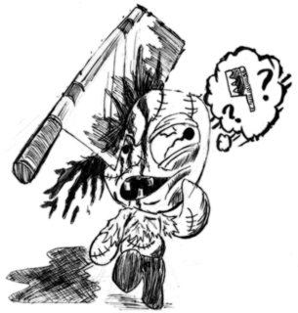

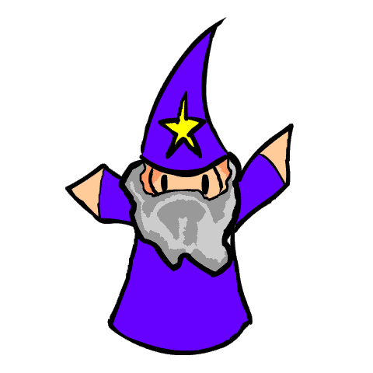
Development Credits
ORIGINAL GAME DESIGNERS
Aaron Bishop aka Programmer X
Benjamin Bishop

LEAD DESIGNER
Johan Jansen aka Zefz

PREVIOUS LEAD DESIGNER
Alazimir

LEAD CODERS
Ben Birdsey
Jonathan Fischer

CODING
Arakon
Aleous
Johan Jansen aka Zefz

OPENGL PORTER
Morgan Aldridge
Nicholas Vining
Ted Milker
Daniel Burrows
Gary Clark
Ollipekka Makitalo
Germain Sauv
Francisco Mu aka Paco
Merlin Avery
Dan Olson
William Tan Heok Wee
Ryan Thompson
Matt Adam
Christophe Beauregards
Christian Laforte

LEVEL DESIGN
Johan Jansen aka Zefz
Florian Natterer aka Clonkinator
PurpleSquerkle

ModBaker Map Editor
Xenom[GER]

SOUND AND VOICE
Aleous
Mycorf
Johan Jansen aka Zefz
Leviticus

MUSIC
Klastek Timrak
Edward Blakely aka eddyster

MODELLING
Johan Jansen aka Zefz
John Dick aka Booger
Ben Weiss aka Cimeries aka Chainsaw aka "That damn kid".
Ben Birdsey
Ptapasu
Icezd

ARTWORK
Kalle Suhonen aka Woodmouse
Ben Weiss aka Cimeries aka Chainsaw
Hiroy
John Dick aka Booger
Benjamin Birdsey aka bgbirdsey
PurpleSquerkle

LINUX SUPPORT
Hans de Goede
Penguinflyer5234

MACINTOSH SUPPORT
Ben Urban
Jonathan Fischer
WEBSITE DESIGNER
PurpleSquerkle

LEAD BETA TESTER
Florian Natterer aka Clonkinator
Johan Jansen aka Zefz

BETA TESTERS
Benjamin Birdsey aka bgbirdsey
HyugaNeji
Ben Weiss aka Cimeries aka Chainsaw
Ben Urban
penguinflyer5234
penguinflyer2222
Alex aka Maxaxle
Feenfleisch
Kalle Suhonen aka woodmouse
PurpleSquerkle

SPECIAL THANKS TO
Arne Kristian Jansen aka Aigle
eatsonlyheads
Golem
Veiva
Agent of Dread (Have a cookie!)
Freegamer
Denis Jaimes

And all you others out there who have helped
contribute to this wonderful game!

And special thanks for the support from the Sourceforge team!
OLD ZIPPY EGOBOO TEAM

LEAD DESIGNER ZIPPY EGOBOO
Matty Noble aka Elmin

CODING
Arakon
Paul Müller aka bitnapper
Aleous

ARTWORK
Hunna
Spyro
AiletheAlien

MODELLING
Iceczd
Graham Lackey aka Grey Jakal
booger
Pteromys

LEVEL DESIGN
Johan Jansen aka Zefz
John Dick aka Booger
Pteromys

EGOMAP DESIGNER
Arakon

THANKS TO
Goldenbeast
Sneakeye
Gargoyle
MR?
eatsonlyheads
Klohnish B aka pinkelephant
Barnaby-James Astles
Adam Chamberlin
Mike Holt
ioquan

